Mr. Toothy



By Team 18

Overview

Mr. Toothy is the face of Joaquina Dental Clinic, and is the visual manifestation of the brand personality. Mr. Toothy’s clean and shiny appearance communicates the clinic’s mission to offer the best quality dental care to its customers, and his cheerful visage conveys that the brand is always excited to serve the customers.

Mr. Toothy cracks witty jokes to welcome customers as soon as they visit the website. His amiable persona makes the customer’s dental reservation process an extremely jubilant experience. He often carries various dental products that reminds customers about their dental hygiene.

Mr. Toothy offers great help to the customers while using the application. While he offers a few giggles with his witty statements, his dental hygiene tips help customers stay wise.

Brand Traits



FRIENDLY *but not annoying*



FUNNY *but not goofy*



TRUSTWORTHY *but not prosaic*



SURPRISING *but not shocking*



EASY *but not simplistic*



INFORMAL *but not clumsy*

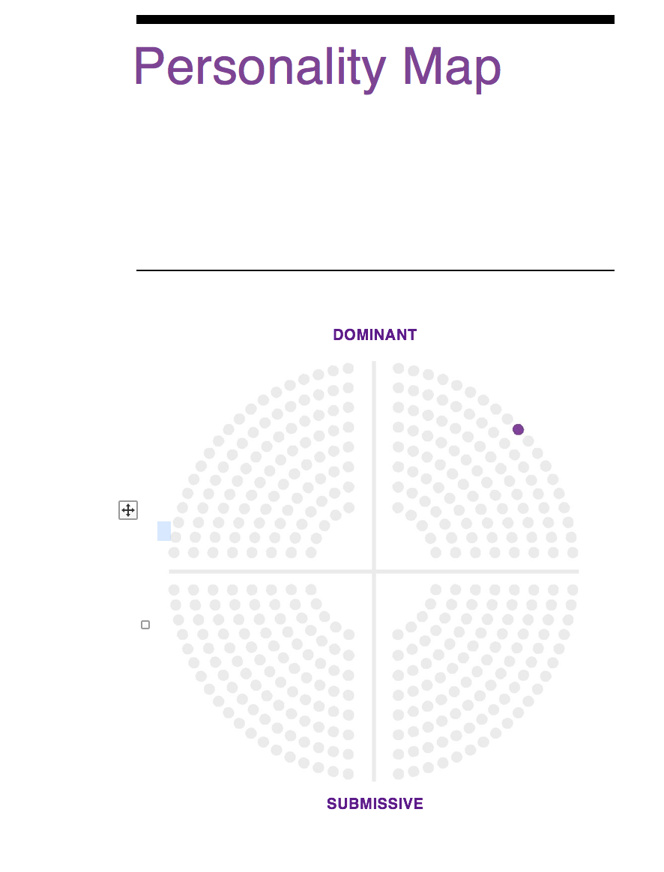

Voice

The voice of Mr. Toothy is familiar, personal and trustworthy. The personalities of people behind the brand shines through with trust and confidence. Mr. Toothy is compassionate and patient just like a doctor would do in dire circumstances. Mr. Toothy is cute, hilarious and is a very lovable personality.

Mr. Toothy is very easy going and provides a proper direction to the users. Mr. Toothy is aware of the situations patients could be in and tries to understand the view from a patient’s perspective. Mr. Toothy never discourages a patient by giving direct negative replies. It ignites hope in patients and inspires them to remain fit and healthy. Mr. Toothy uses phrases like “Hey! I see you again.” and “How are you doing today?” to show his compassion and friendliness. It says “Sorry for the inconvenience” to show empathy to the user while accessing the website.

Mr. Toothy sometimes loves to show off its success by talking about their huge customer base and display their positive testimonials to the clinic. It also accepts whenever it commits a mistake or when network issues cause users to become frustrated by displaying messages like “Sorry! Network just broke down” and “Apologize for the delay” or “We’ll be right back with you”.

Voice (continued)

COPY EXAMPLES

**In App Greeting**

Hey, Steve. Looks like you’ve an early start today.

**Success Feedback**

Yay! Your payment went through.

**Error Feedback**

Ooh! We’ve already registered with this email address.

**General Message**

Huh! Seems you don’t have any appointments scheduled.

**Critical Failure**

Our network is currently unavailable. Our team is working to fix the issue. Hope you check the site again.



**Marketing Copy**

We’re connected to all kinds of social network. We want you to share your story on Facebook, Twitter and so on with millions around you and inspire them to take care of their tooth better.

Visual Lexicon

### COLOR

The use of natural blue color in Mr. Toothy is to convey a calm and soothing feeling. White is used to contrast the blue color and also as a symbol of health and strength. Mr. Toothy is fun and lively and at the same time asserts the message of maintaining a good dental hygiene. The color scheme sets a welcoming tone for the patients.

### TYPOGRAPHY

The website of our Dental clinic is efficient, professional and easy to use. Simple sans-serif headings and body copy appropriately varied in scale, weight and use of contrasting color. The entire design maintains a familiar and comfortable outlook and tries to build confidence and loyalty with customers.

The typography of the website is designed considering the varied customer base and their expectations from the site. Simple design promotes higher usability for older clients while the witty appearance of Mr. Toothy caters to the children and the teenage patients. A sophisticated and organized arrangement is employed mainly for the tech-savvy, working professionals. And finally a clutter-free design increases the overall usability of the site.

### GENERAL STYLE NOTES

Interface elements are kept simple and uncluttered. Accessibility has been the driving factor in the design with an emphasis on ease to understand. Subtle textures are used to imbibe a feeling of trust and confidence.

Mr. Toothy is used occasionally, mainly to convey dental and hygiene tips along with funny compliments. Mr. Toothy does not provide information about operations or services of the clinic.

Engagement Methods

### Surprise & Delight

The customers would be surprised and the delighted right from the login page. The login page would not only be themed but an animated form would be provided to wow the visitors.

Animated pre loaders would be used to provide visual cue while loading the content in the background. Finally, tooltips would be used to onboard new users and convert them to active users.

### Anticipation

Funny greetings would be displayed on the top of the page based on the patient's previous ailment and a funny welcome note would be given for a new user. Frequently asked questions (FAQ's) with answers would be provided and most importantly, a facility to chat live with a customer service representative would be provided.

### Rewards

Various surveys would be conducted to improve customer service at the dental clinic based on the treatment and a reward of 5% off on the doctor fee would be offered to complete the survey. Also, a complimentary doctor recommended sample tooth paste would be given away for free to patients who reserve the appointments through the website.